Boss of the SOC v1

Level 1

Finding Attack Servers

BOTSv1 1.1: Scanner Name (5 pts)
Find the brand name of the vulnerability scanner, covered by a green box in the image above

A:
Query: index="botsv1" sourcetype="stream:http" imreallynotbatman.com
Next Find the vulnerability scanner name

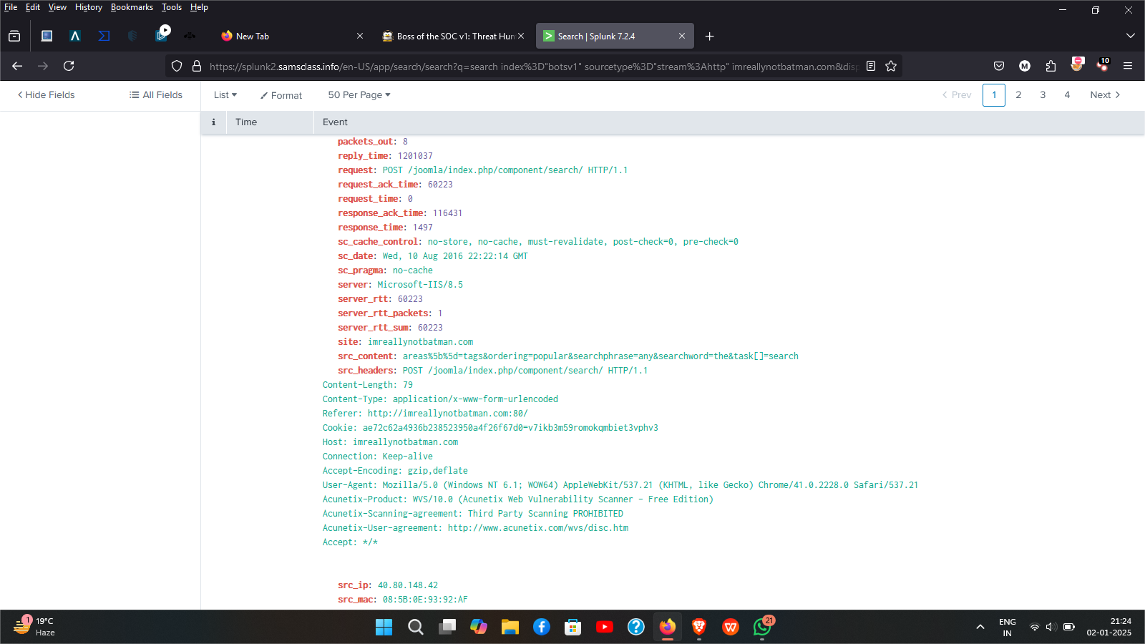

- The brand name of the vulnurability scanner “acunetix”

BOTSv1 1.2: Attacker IP (5 pts)
Find the attacker's IP address.

A:
Query:index="botsv1" sourcetype="stream:http" imreallynotbatman.com
The attacker ip address 40.80.148.42

- The attacker ip address 40.80.148.42

BOTSv1 1.3: Web Server IP (5 pts)

Find the IP address of the web server serving "imreallynotbatman.com".

A:
Query:index="botsv1" sourcetype="stream:http" imreallynotbatman.com
The attacker ip address 40.80.148.42

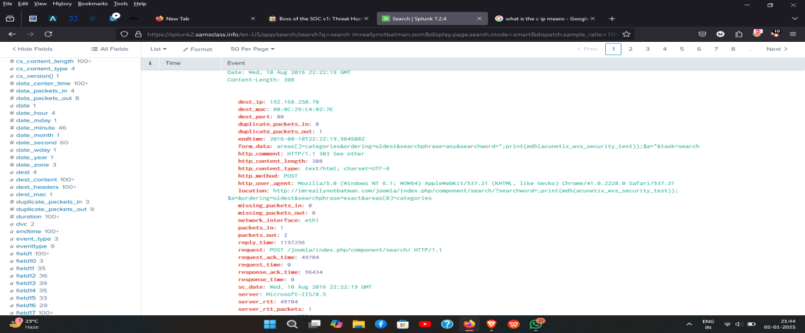

- The ip address of the web server 192.168.250.70(imreallynotbatman.com)

BOTSv1 1.4: Defacement Filename (10 pts)/
Find the name of the file used to deface the web server serving "imreallynotbatman.com".

A:
Query : index=botsv1 sourcetype=stream:http src_ip=192.168.250.70
| table site src_headers
This is index.php file(fake file name/visually modified)

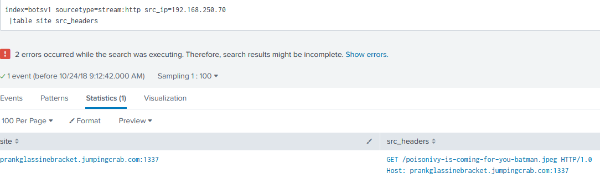
Query: index=botsv1 sourcetype=suricata http_method=GET NOT
imreallynotbatman.com src_ip="23.22.63.114"
http.length"=107276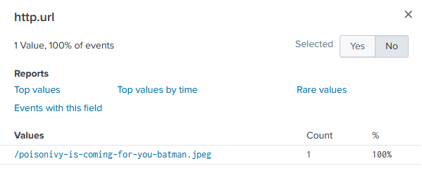

- http.url field contains the suspicious file "/poisonivy-is-coming-for-you-batman.jpeg"

BOTSv1 1.5: Domain Name (10 pts)
Find the fully qualified domain name (FQDN) used by the staging server hosting the defacement file.
A: The fully qualified domain name is prankglassinebracket.jumpingcrab.com
- Based on Q5

